Medicine Grand Rounds

"Role of Renal Replacement Therapy in Critical Care"
Wednesday, Feb. 27, 2019| Noon-1 p.m.

Watch It LIVE!
(or archived here for later viewing)

Bijin Thajudeen, MD
Associate Professor of Medicine, UA Division of Nephrology
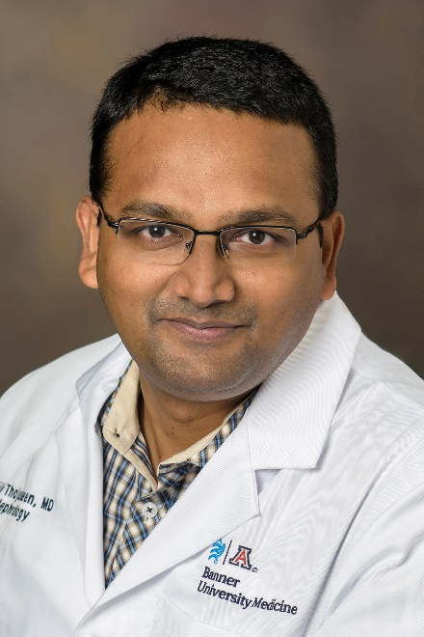

WHERE TO GO:
UA College of Medicine – Tucson, Room 5403  1501 N. Campbell Ave.  Tucson, AZ 85724  (In person) | Banner – UMC South, Conference Room 3030  2800 E. Ajo Way  Tucson, AZ 85713  (Via video conference)

A light lunch will be served.

Accreditation Statement: The University of Arizona College of Medicine – Tucson is accredited by the Accreditation Council for Continuing Medical Education to provide continuing medical education for physicians. The college designates this live activity for a maximum of 1 AMA PRA Category 1 Credit(s) ™. Physicians should claim only the credit commensurate with the extent of their participation in the activity.

Disclosure Statement(s): All Faculty, CME Planning Committee Members, and CME Office Reviewers have disclosed that they have no financial relationships with commercial interests that would constitute a conflict of interest concerning this CME activity.

Learning Objectives:
1. Diagnose a variety of internal medicine illnesses;
2. Understand more clearly advances in therapy, and
3. Become truly professional physicians

